|  |
| --- |
| ISUBU |
| Mobil Programlama 1 Vize Sınav |
| ***Halit Çetiner***  AD SOYAD: ALİ BARAN  NO: 1915010061 |

## ÇALIŞAN EKRAN GÖRÜNTÜLERİ (20puan)

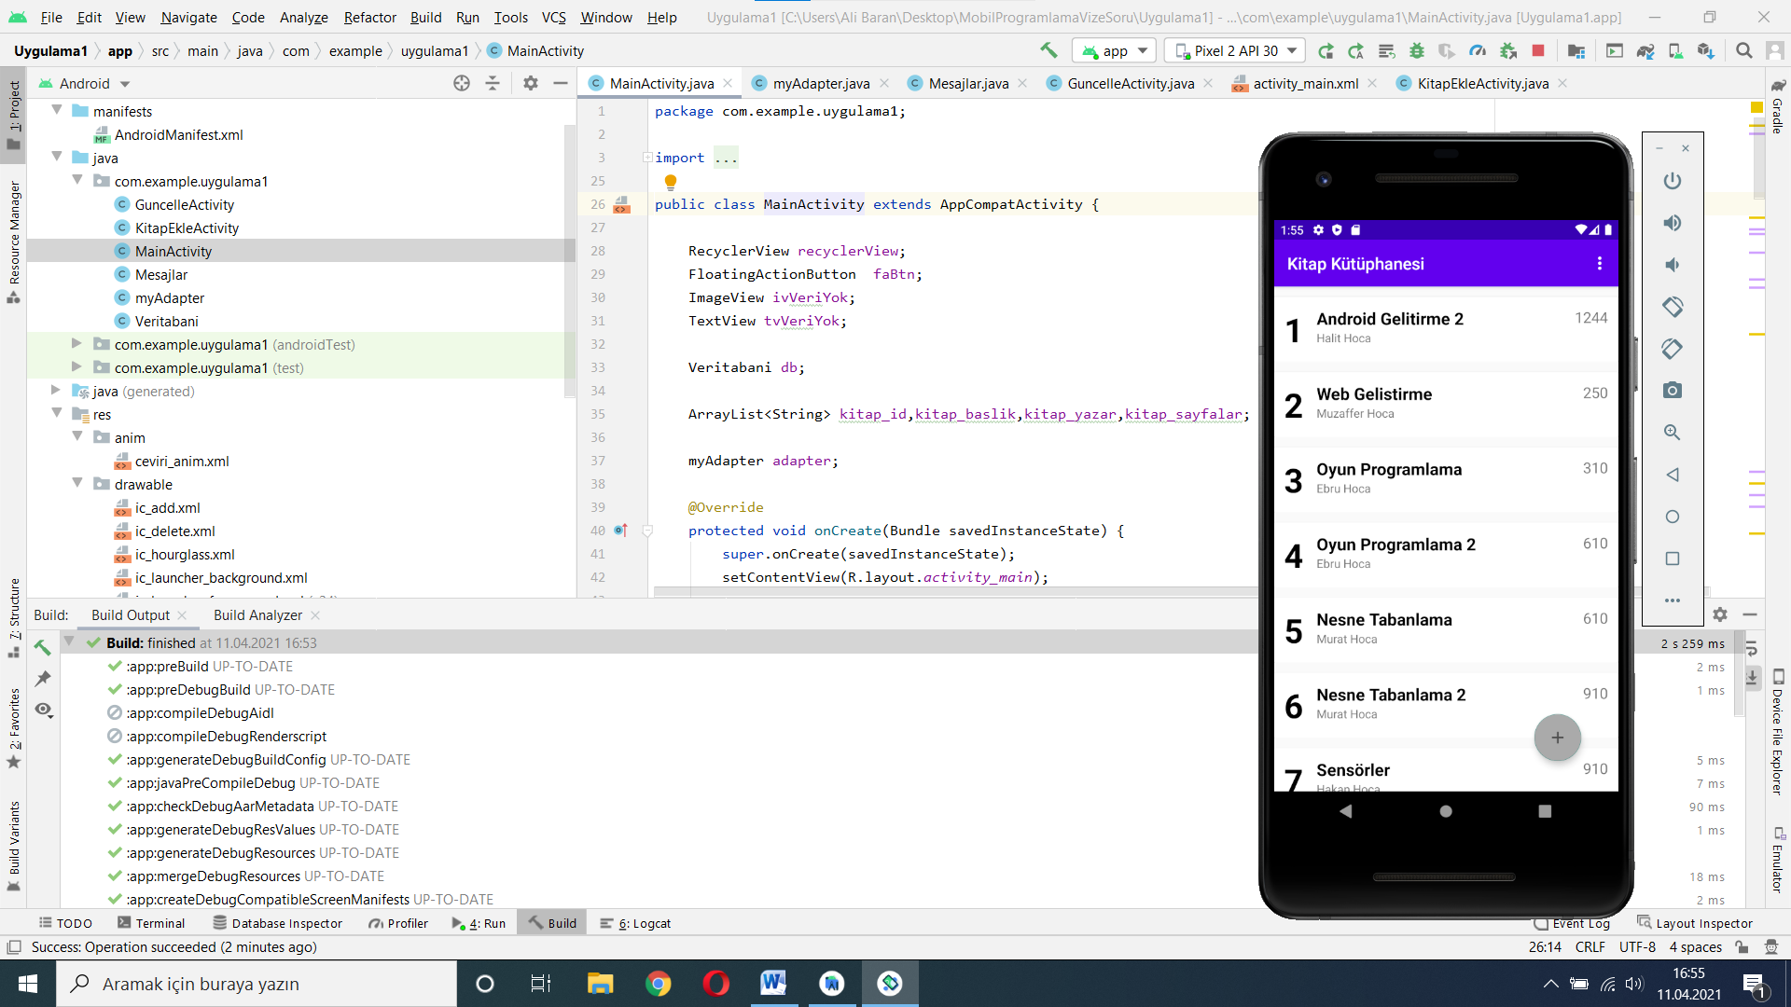

**Şekil 1. Çalışan Ekran Görüntüsü Formatı**

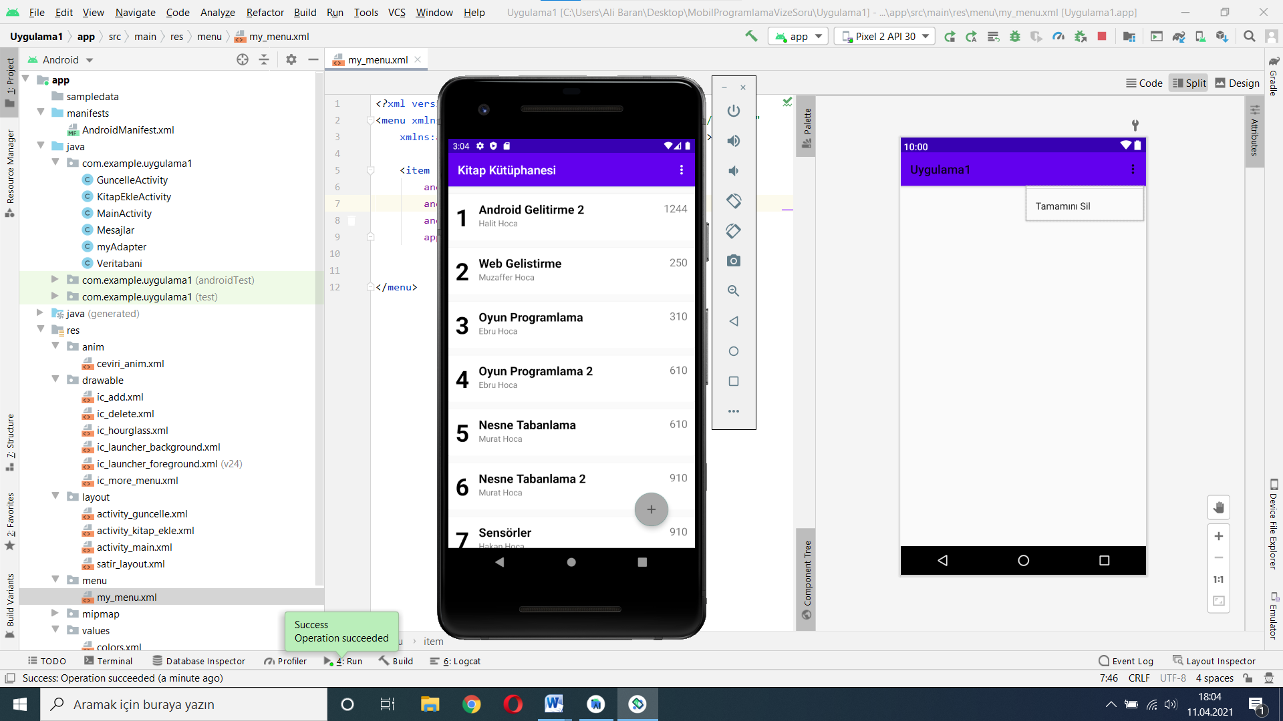

**Şekil 2.Güncelleme Öncesi, ana ekran satır seçimi ve güncelleme ekranına geçiş**

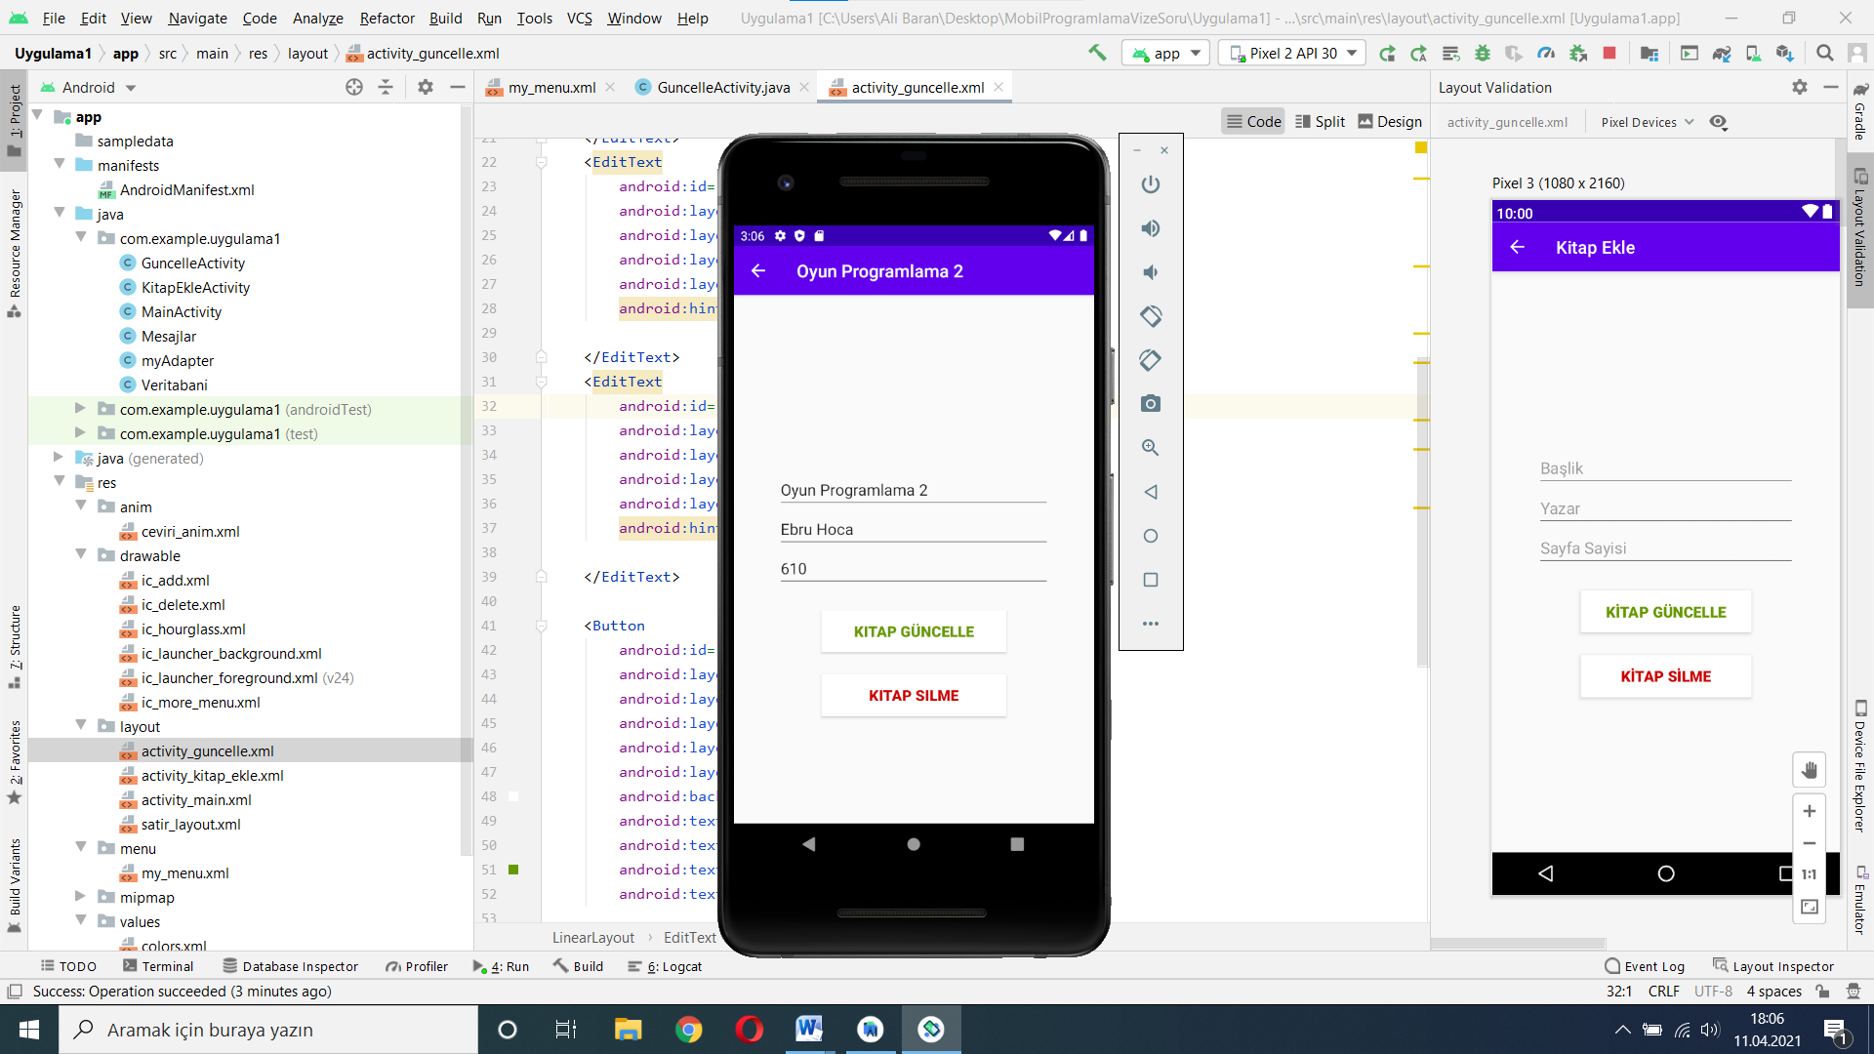

**Şekil 3.Güncelleme Veri Giriş Ekranı**

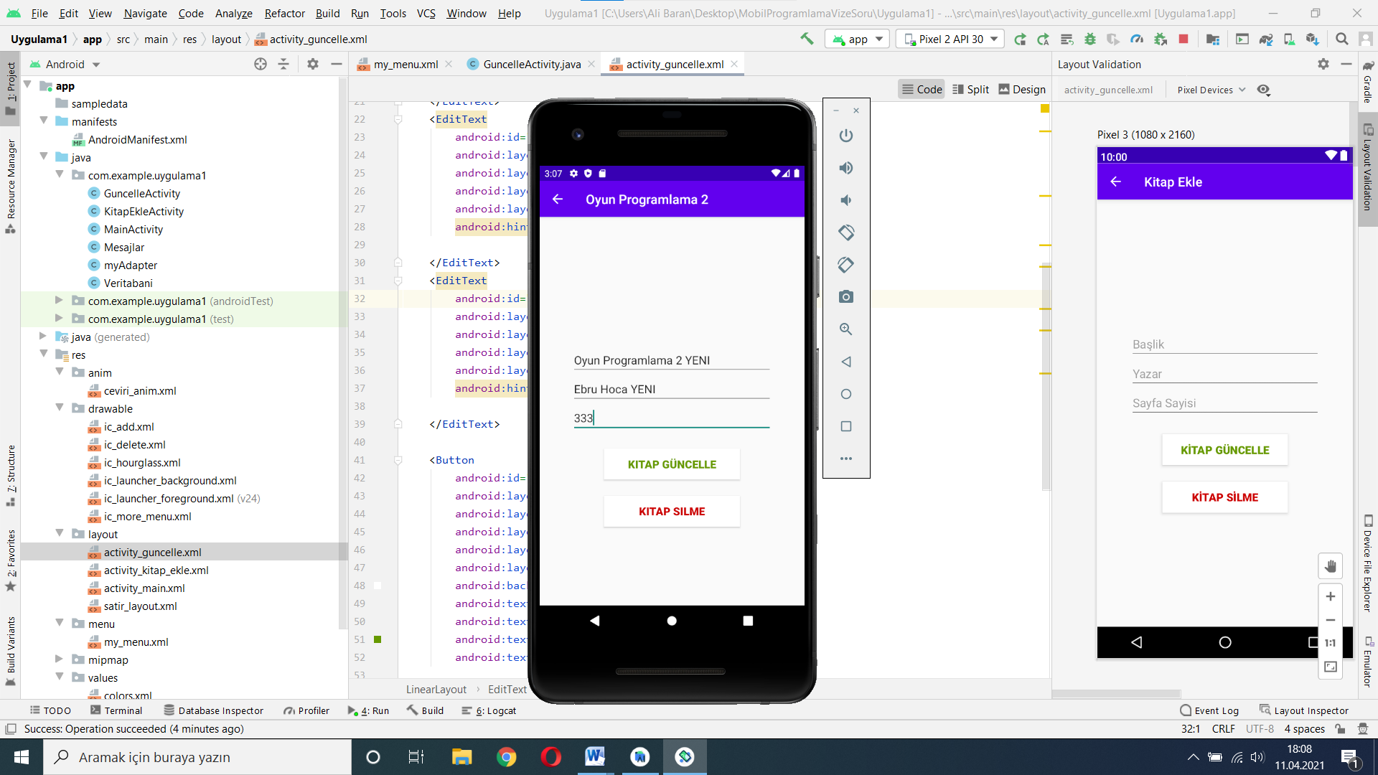

**Şekil 4.Güncelleme Veri Giriş Ekranı GÜNCELLENMİŞ**

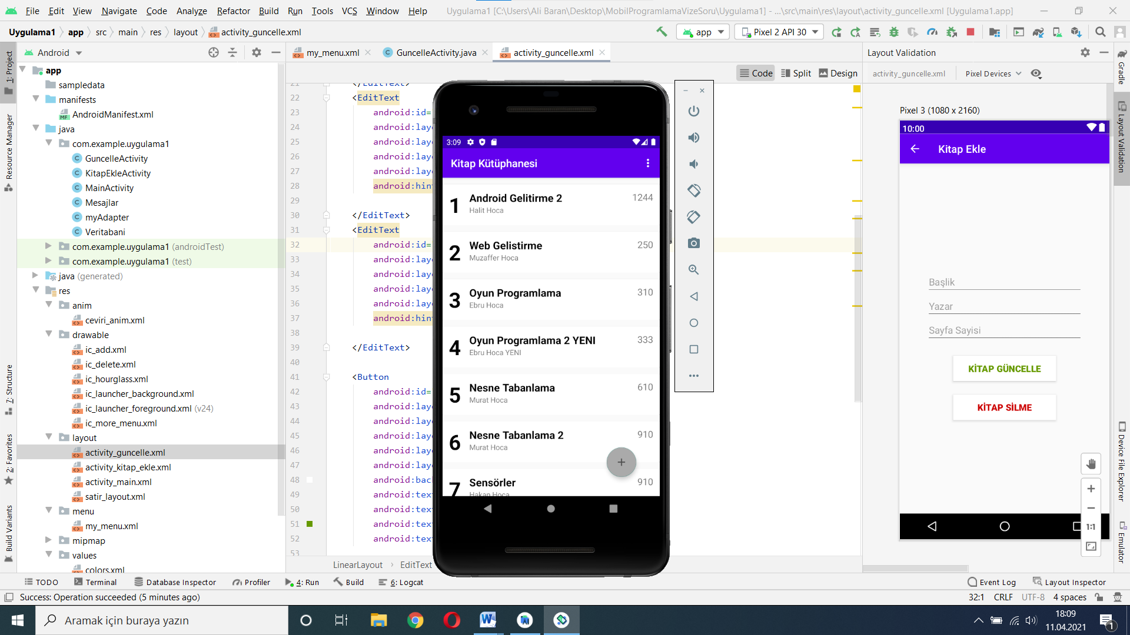

**Şekil 5.Güncelleme Sonrası, Ana Ekran**

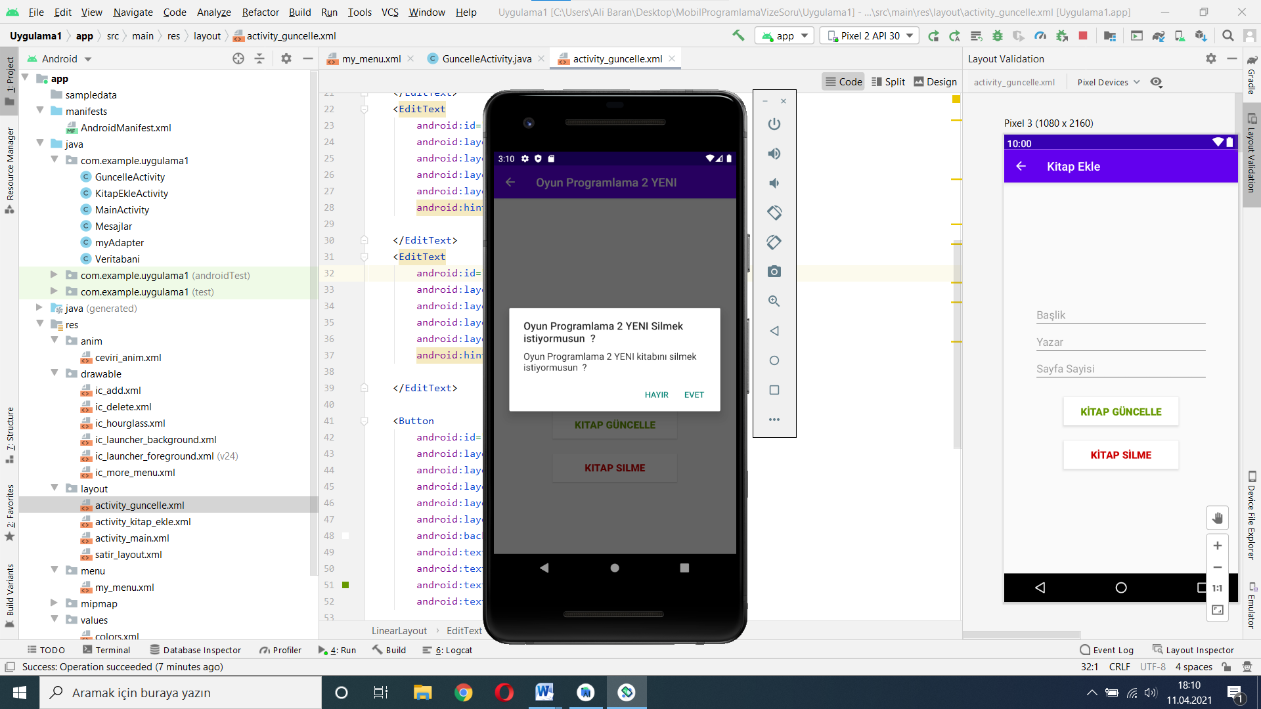

**Şekil 6.Silme sonrasında uyarı ekranı**

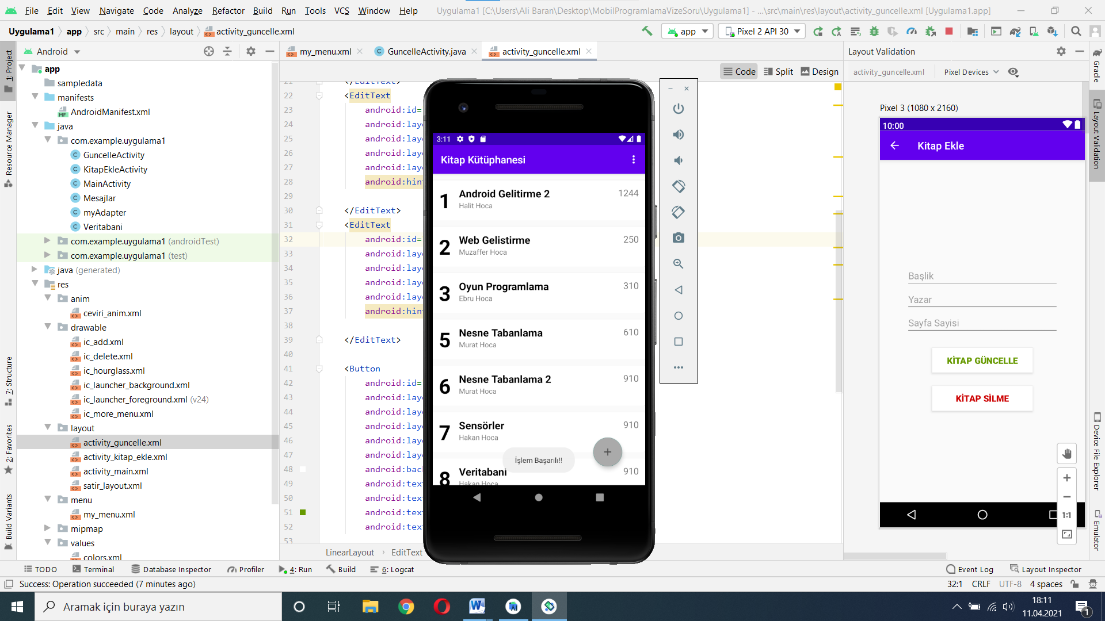

**Şekil 7.Silme sonrasında Ana ekranı DÖNER**

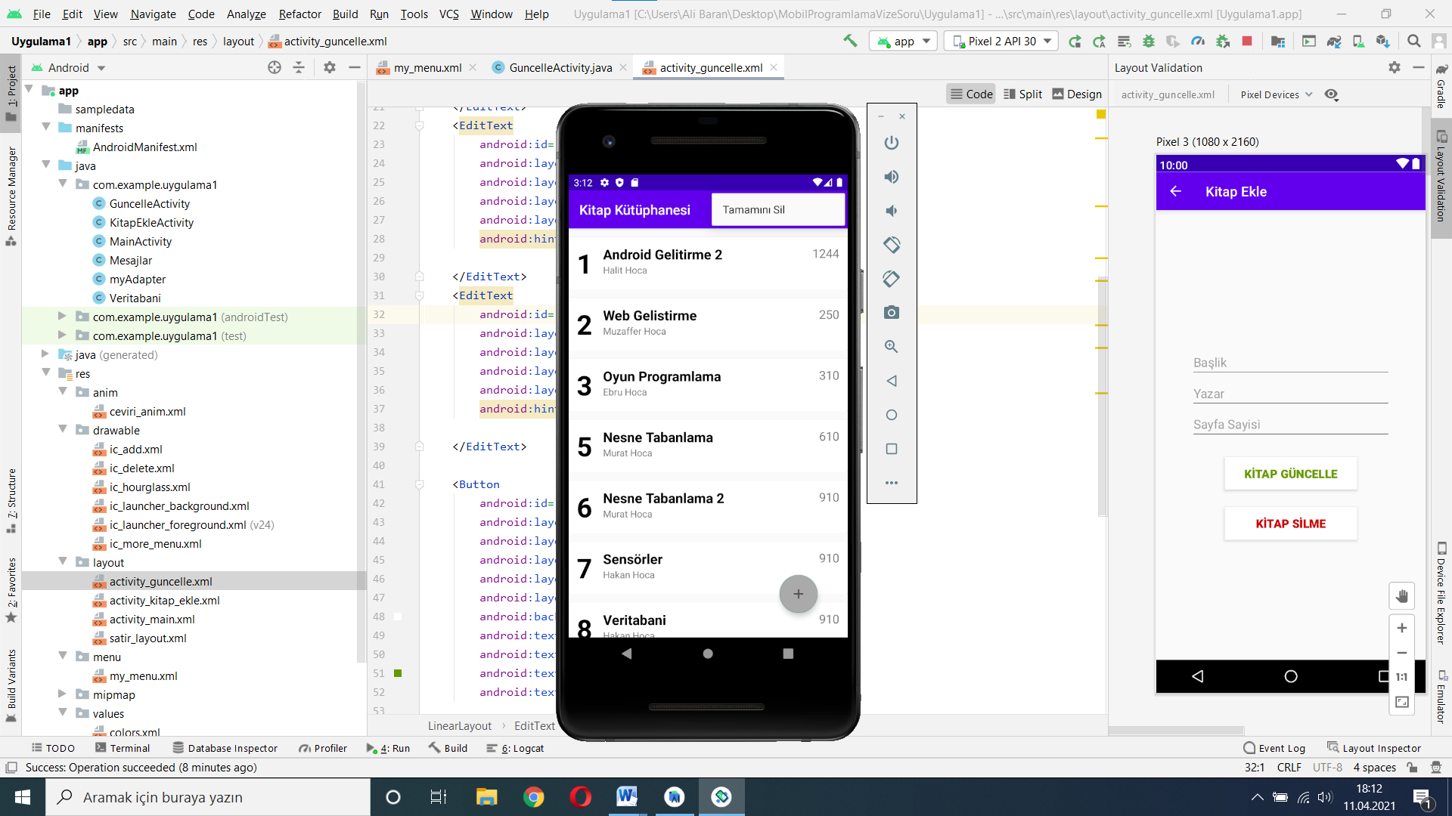

**Şekil 8.Tamamını Silme Öncesi**

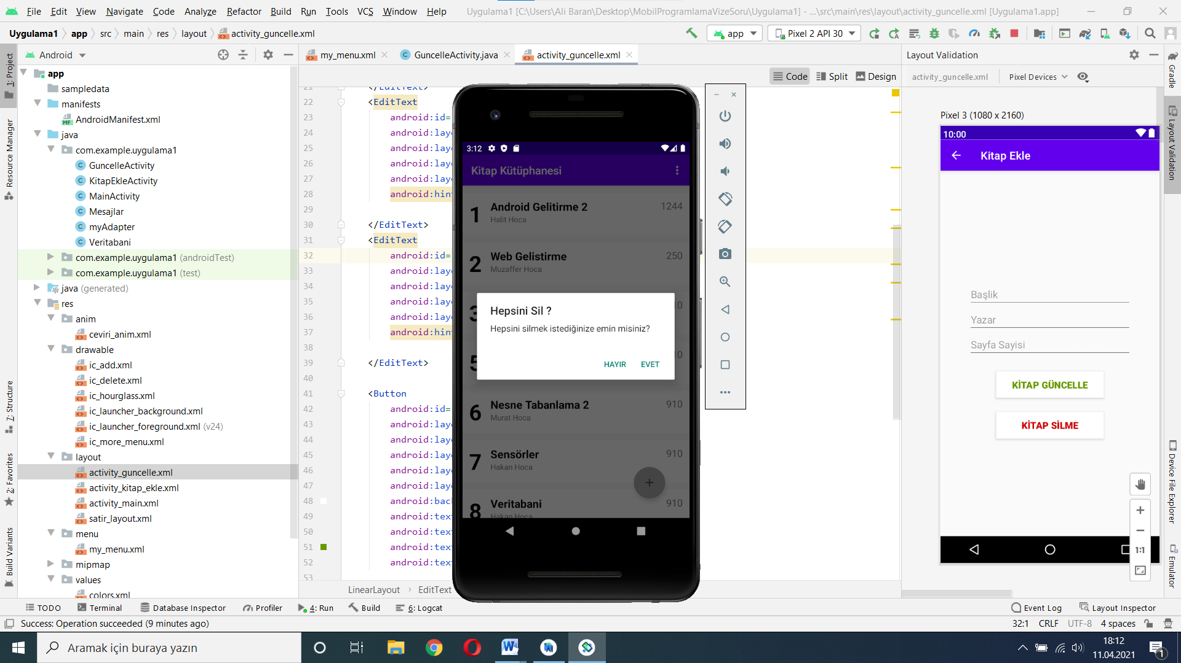

**Şekil 9.Tamamını Silme Dialog**

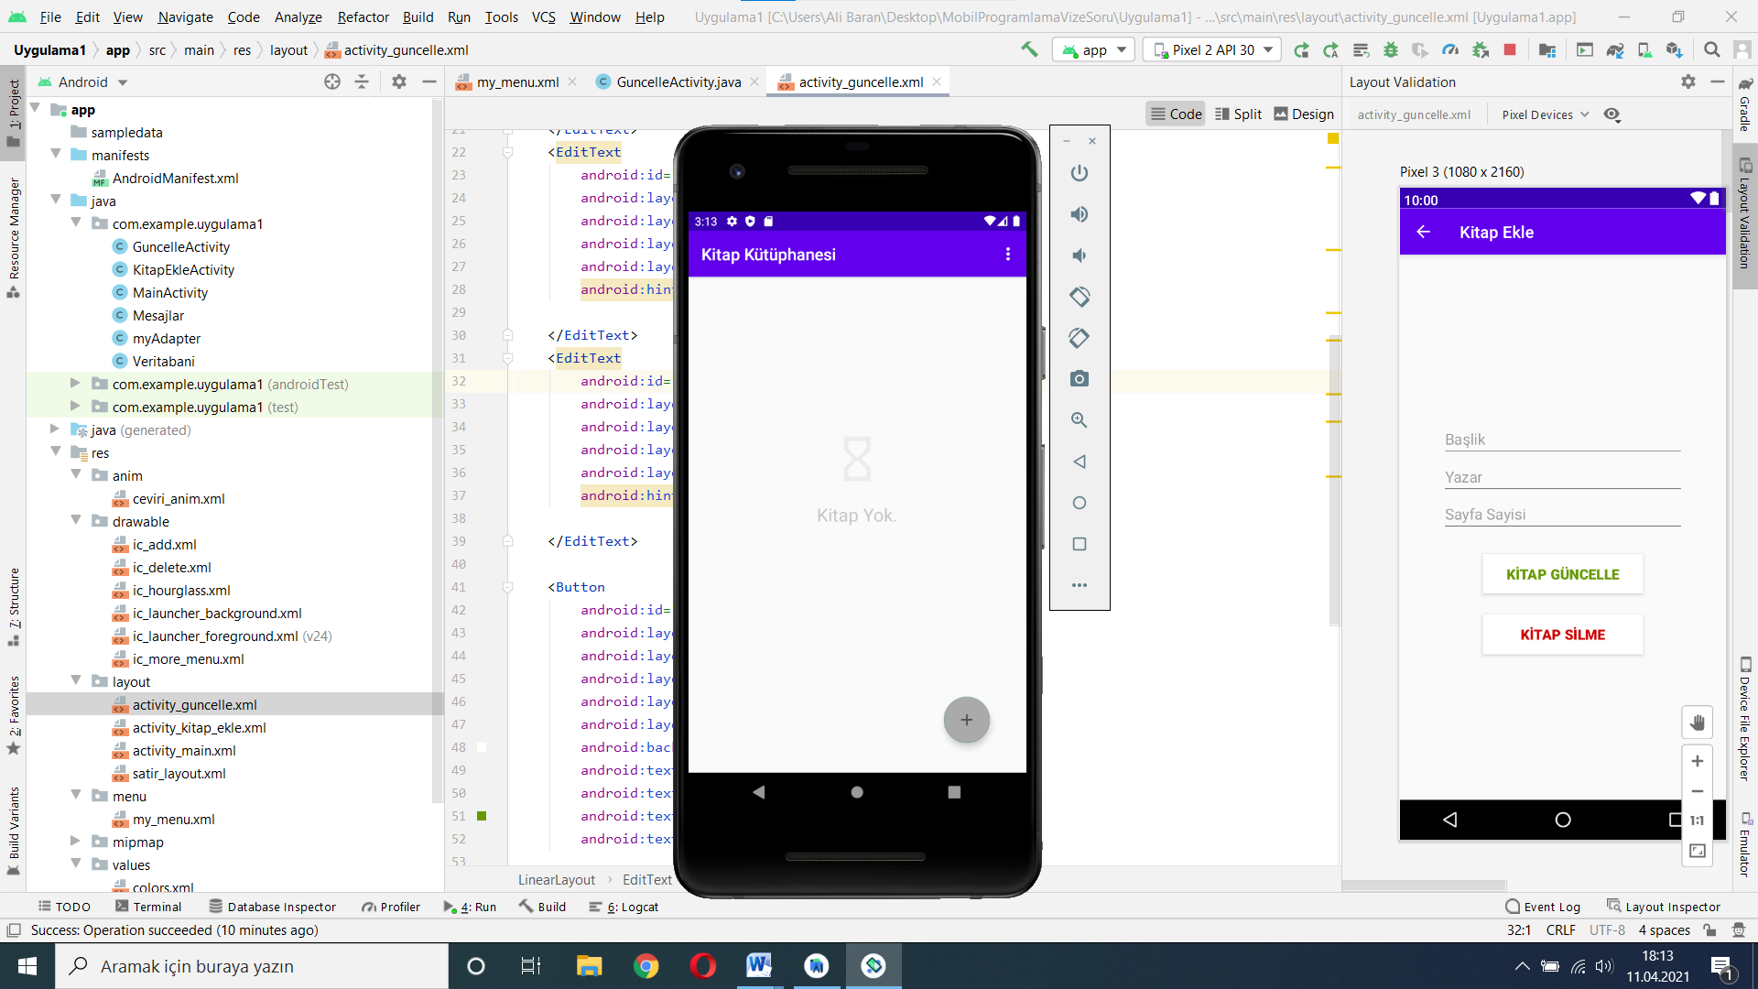

**Şekil 10.Tamamını Silme Sonrası**

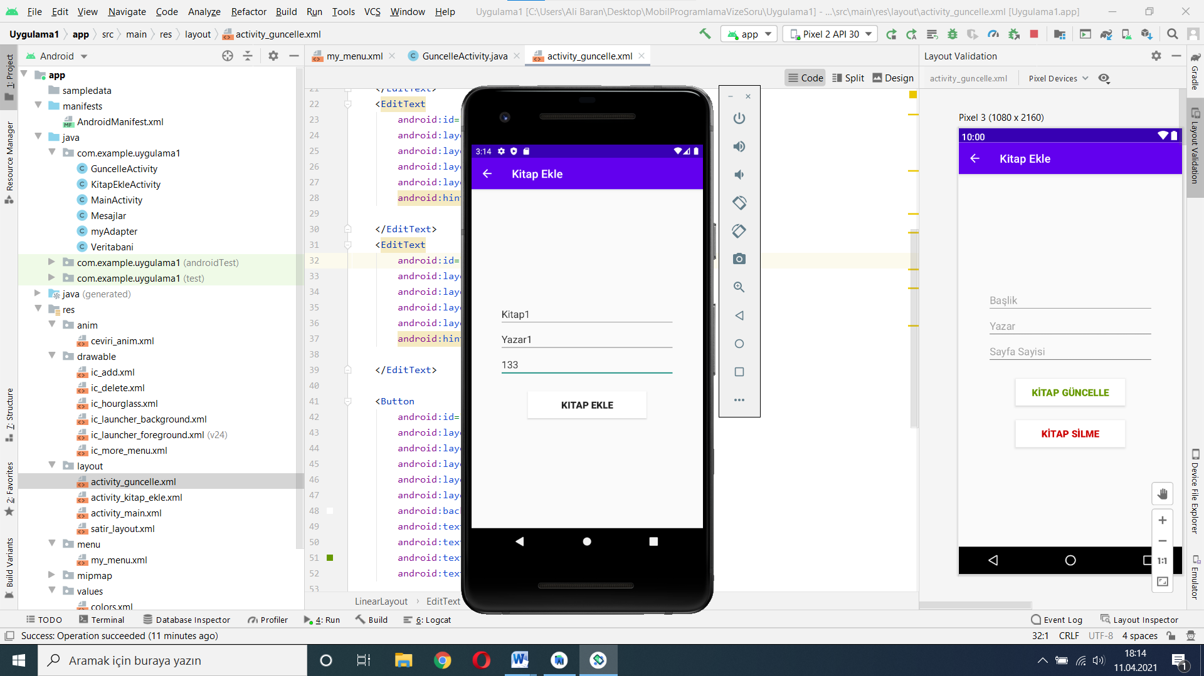

**Şekil 11.EKLEME ÖNCESİ**

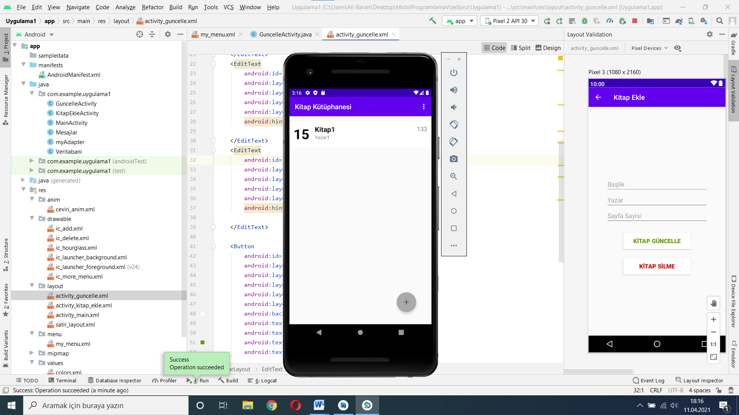

**Şekil 12.EKLEME SONRASI**

## String.xml

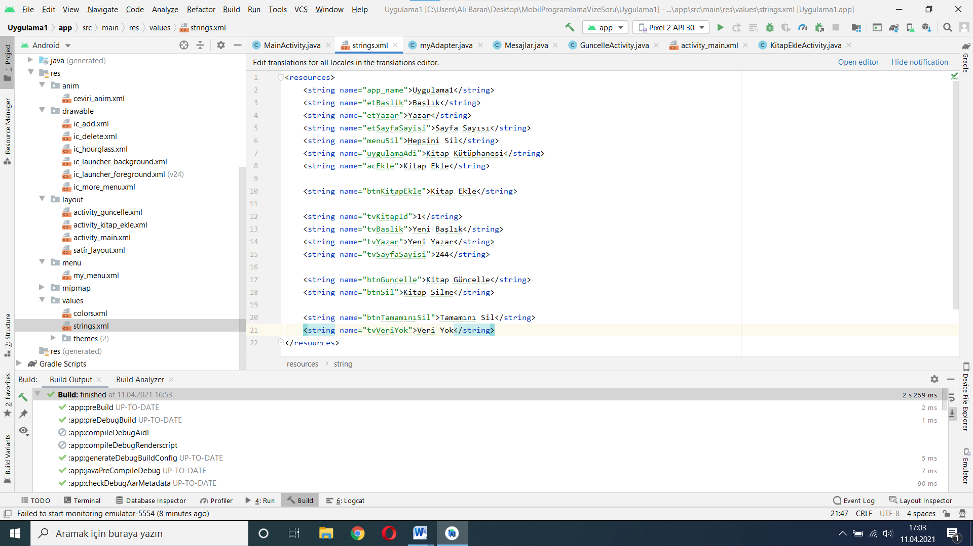

**Şekil 13.String.xml**

## ceviri_anim.xml (Animasyon Dosyası) (10 puan)

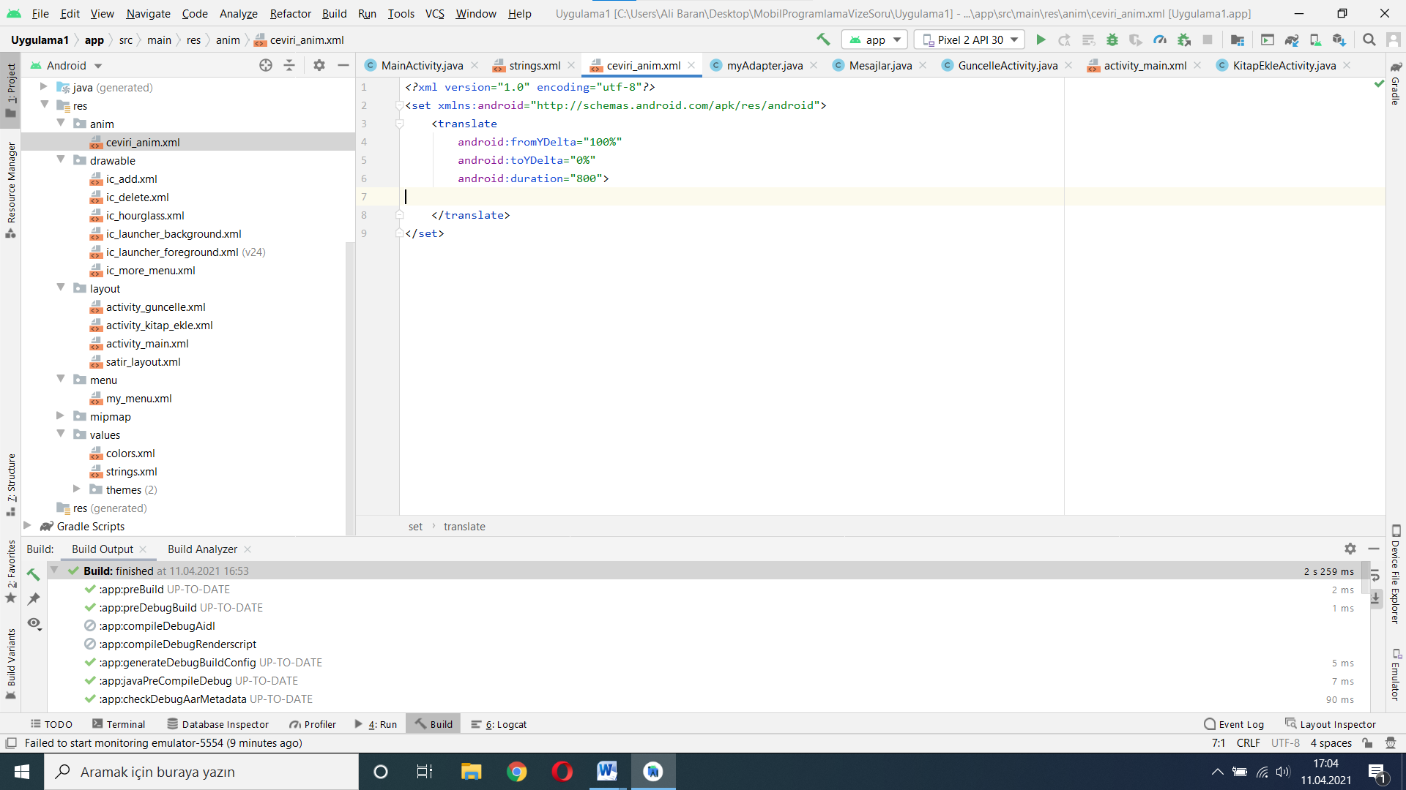

**Şekil 14.ceviri_anim.xml**

## Activity_main.xml (30 puan)

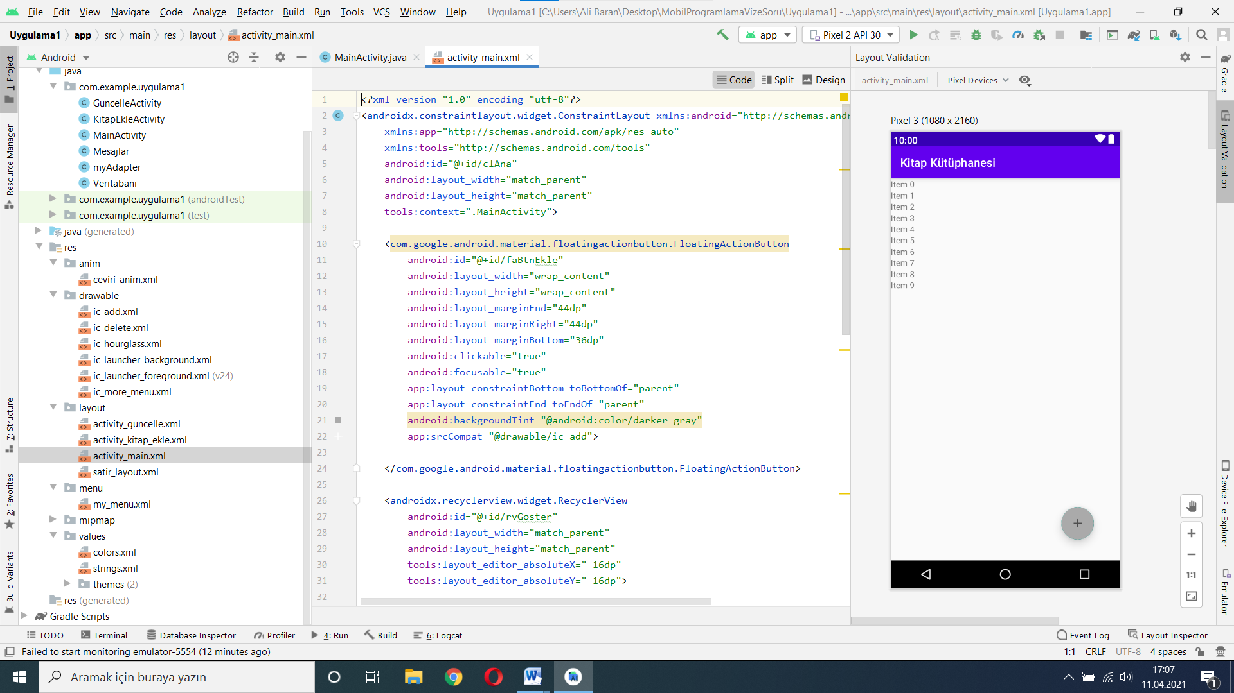

**Şekil 15.activity_main.xml**

KOD KISMI:

*<?*xml version="1.0" encoding="utf-8"*?>*<androidx.constraintlayout.widget.ConstraintLayout xmlns:android="http://schemas.android.com/apk/res/android"  
 xmlns:app="http://schemas.android.com/apk/res-auto"  
 xmlns:tools="http://schemas.android.com/tools"  
 android:id="@+id/clAna"  
 android:layout_width="match_parent"  
 android:layout_height="match_parent"  
 tools:context=".MainActivity">  
  
 <com.google.android.material.floatingactionbutton.FloatingActionButton  
 android:id="@+id/faBtnEkle"  
 android:layout_width="wrap_content"  
 android:layout_height="wrap_content"  
 android:layout_marginEnd="44dp"  
 android:layout_marginRight="44dp"  
 android:layout_marginBottom="36dp"  
 android:clickable="true"  
 android:focusable="true"  
 app:layout_constraintBottom_toBottomOf="parent"  
 app:layout_constraintEnd_toEndOf="parent"  
 android:backgroundTint="@android:color/darker_gray"  
 app:srcCompat="@drawable/ic_add">  
  
 </com.google.android.material.floatingactionbutton.FloatingActionButton>  
  
 <androidx.recyclerview.widget.RecyclerView  
 android:id="@+id/rvGoster"  
 android:layout_width="match_parent"  
 android:layout_height="match_parent"  
 tools:layout_editor_absoluteX="-16dp"  
 tools:layout_editor_absoluteY="-16dp">  
  
 </androidx.recyclerview.widget.RecyclerView>  
  
 <ImageView  
 android:id="@+id/ivVeriYok"  
 android:layout_width="81dp"  
 android:layout_height="65dp"  
 app:layout_constraintBottom_toBottomOf="parent"  
 app:layout_constraintEnd_toEndOf="parent"  
 app:layout_constraintStart_toStartOf="parent"  
 app:layout_constraintTop_toTopOf="parent"  
 app:layout_constraintVertical_bias="0.351"  
 app:srcCompat="@drawable/ic_hourglass"  
 android:alpha="0.1"  
 android:visibility="gone">  
  
 </ImageView>  
  
 <TextView  
 android:id="@+id/tvVeriYok"  
 android:layout_width="wrap_content"  
 android:layout_height="wrap_content"  
 android:layout_marginTop="20dp"  
 android:text="Kitap Yok."  
 android:textSize="22sp"  
 app:layout_constraintEnd_toEndOf="parent"  
 app:layout_constraintStart_toStartOf="parent"  
 app:layout_constraintTop_toBottomOf="@+id/ivVeriYok"  
 android:visibility="gone"  
 android:alpha="0.4"/>  
  
  
</androidx.constraintlayout.widget.ConstraintLayout>

MainActivity.java

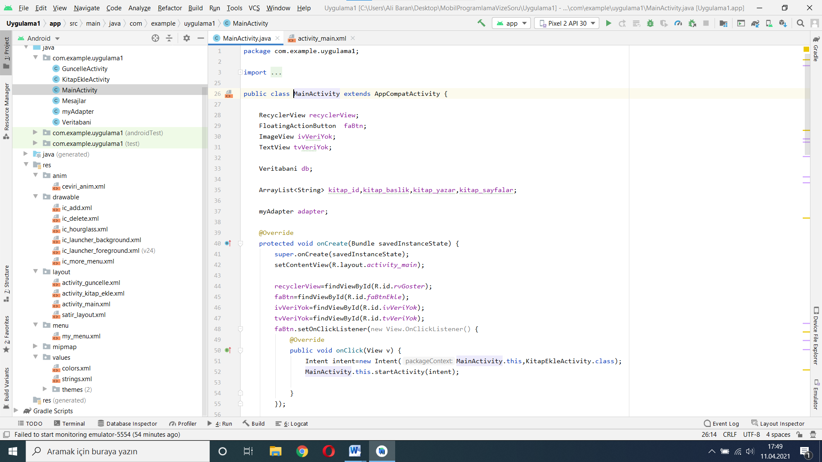

**Şekil 16.activity_main.java**

KOD KISMI:

import java.util. package com.example.uygulama1;  
  
import androidx.annotation.NonNull;  
import androidx.annotation.Nullable;  
import androidx.appcompat.app.AlertDialog;  
import androidx.appcompat.app.AppCompatActivity;  
import androidx.recyclerview.widget.LinearLayoutManager;  
import androidx.recyclerview.widget.RecyclerView;  
  
import android.content.DialogInterface;  
import android.content.Intent;  
import android.database.Cursor;  
import android.os.Bundle;  
import android.view.Menu;  
import android.view.MenuInflater;  
import android.view.MenuItem;  
import android.view.View;  
import android.widget.ImageView;  
import android.widget.TextView;  
import android.widget.Toast;  
  
import com.google.android.material.floatingactionbutton.FloatingActionButton;  
  
ArrayList;  
  
public class MainActivity extends AppCompatActivity {  
  
 RecyclerView recyclerView;  
 FloatingActionButton faBtn;  
 ImageView ivVeriYok;  
 TextView tvVeriYok;  
  
 Veritabani db;  
  
 ArrayList<String> kitap_id,kitap_baslik,kitap_yazar,kitap_sayfalar;  
  
 myAdapter adapter;  
  
 @Override  
 protected void onCreate(Bundle savedInstanceState) {  
 super.onCreate(savedInstanceState);  
 setContentView(R.layout.*activity_main*);  
  
 recyclerView=findViewById(R.id.*rvGoster*);  
 faBtn=findViewById(R.id.*faBtnEkle*);  
 ivVeriYok=findViewById(R.id.*ivVeriYok*);  
 tvVeriYok=findViewById(R.id.*tvVeriYok*);  
 faBtn.setOnClickListener(new View.OnClickListener() {  
 @Override  
 public void onClick(View v) {  
 Intent intent=new Intent(MainActivity.this,KitapEkleActivity.class);  
 MainActivity.this.startActivity(intent);  
  
 }  
 });  
  
 db=new Veritabani(MainActivity.this);  
 kitap_id=new ArrayList<>();  
 kitap_baslik=new ArrayList<>();  
 kitap_yazar=new ArrayList<>();  
 kitap_sayfalar=new ArrayList<>();  
  
 KitaplarıGoster();  
 adapter=new myAdapter(MainActivity.this,MainActivity.this,kitap_id,kitap_baslik,kitap_yazar,kitap_sayfalar);  
 recyclerView.setAdapter(adapter);  
 recyclerView.setLayoutManager(new LinearLayoutManager(MainActivity.this));  
  
 }  
  
 @Override  
 protected void onActivityResult(int requestCode, int resultCode, @Nullable Intent data) {  
 super.onActivityResult(requestCode, resultCode, data);  
 if (requestCode==1){  
 recreate();  
 }  
 }  
  
 void KitaplarıGoster(){  
 Cursor cursor=db.KitapListele();  
 if (cursor.getCount()==0){  
 ivVeriYok.setVisibility(View.*VISIBLE*);  
 tvVeriYok.setVisibility(View.*VISIBLE*);  
 }  
 else{  
 while (cursor.moveToNext()){  
 kitap_id.add(cursor.getString(0));  
 kitap_baslik.add(cursor.getString(1));  
 kitap_yazar.add(cursor.getString(2));  
 kitap_sayfalar.add(cursor.getString(3));  
  
 ivVeriYok.setVisibility(View.*GONE*);  
 tvVeriYok.setVisibility(View.*GONE*);  
 }  
 }  
 }  
  
  
 @Override  
 public boolean onCreateOptionsMenu(Menu menu) {  
 MenuInflater inflater=getMenuInflater();  
 inflater.inflate(R.menu.*my_menu*,menu);  
 return super.onCreateOptionsMenu(menu);  
 }  
  
 @Override  
 public boolean onOptionsItemSelected(@NonNull MenuItem item) {  
 if (item.getItemId() == R.id.*menuSil*){  
 SilmeOnayKutusu();  
 }  
 return super.onOptionsItemSelected(item);  
 }  
  
 void SilmeOnayKutusu(){  
 AlertDialog.Builder builder=new AlertDialog.Builder(MainActivity.this);  
 builder.setTitle("Hepsini Sil ?");  
 builder.setMessage("Hepsini silmek istediğinize emin misiniz?");  
 builder.setPositiveButton("Evet", new DialogInterface.OnClickListener() {  
 @Override  
 public void onClick(DialogInterface dialog, int which) {  
 Veritabani db=new Veritabani(MainActivity.this);  
 db.HepsiniKitapSil();  
  
 Intent intent=new Intent(MainActivity.this,MainActivity.class);  
 startActivity(intent);  
 finish();  
  
  
 }  
 });  
 builder.setNegativeButton("Hayır", new DialogInterface.OnClickListener() {  
 @Override  
 public void onClick(DialogInterface dialog, int which) {  
  
 }  
 });  
 builder.create().show();  
 }  
  
  
}

## activity_guncelleme.xml (30 puan)

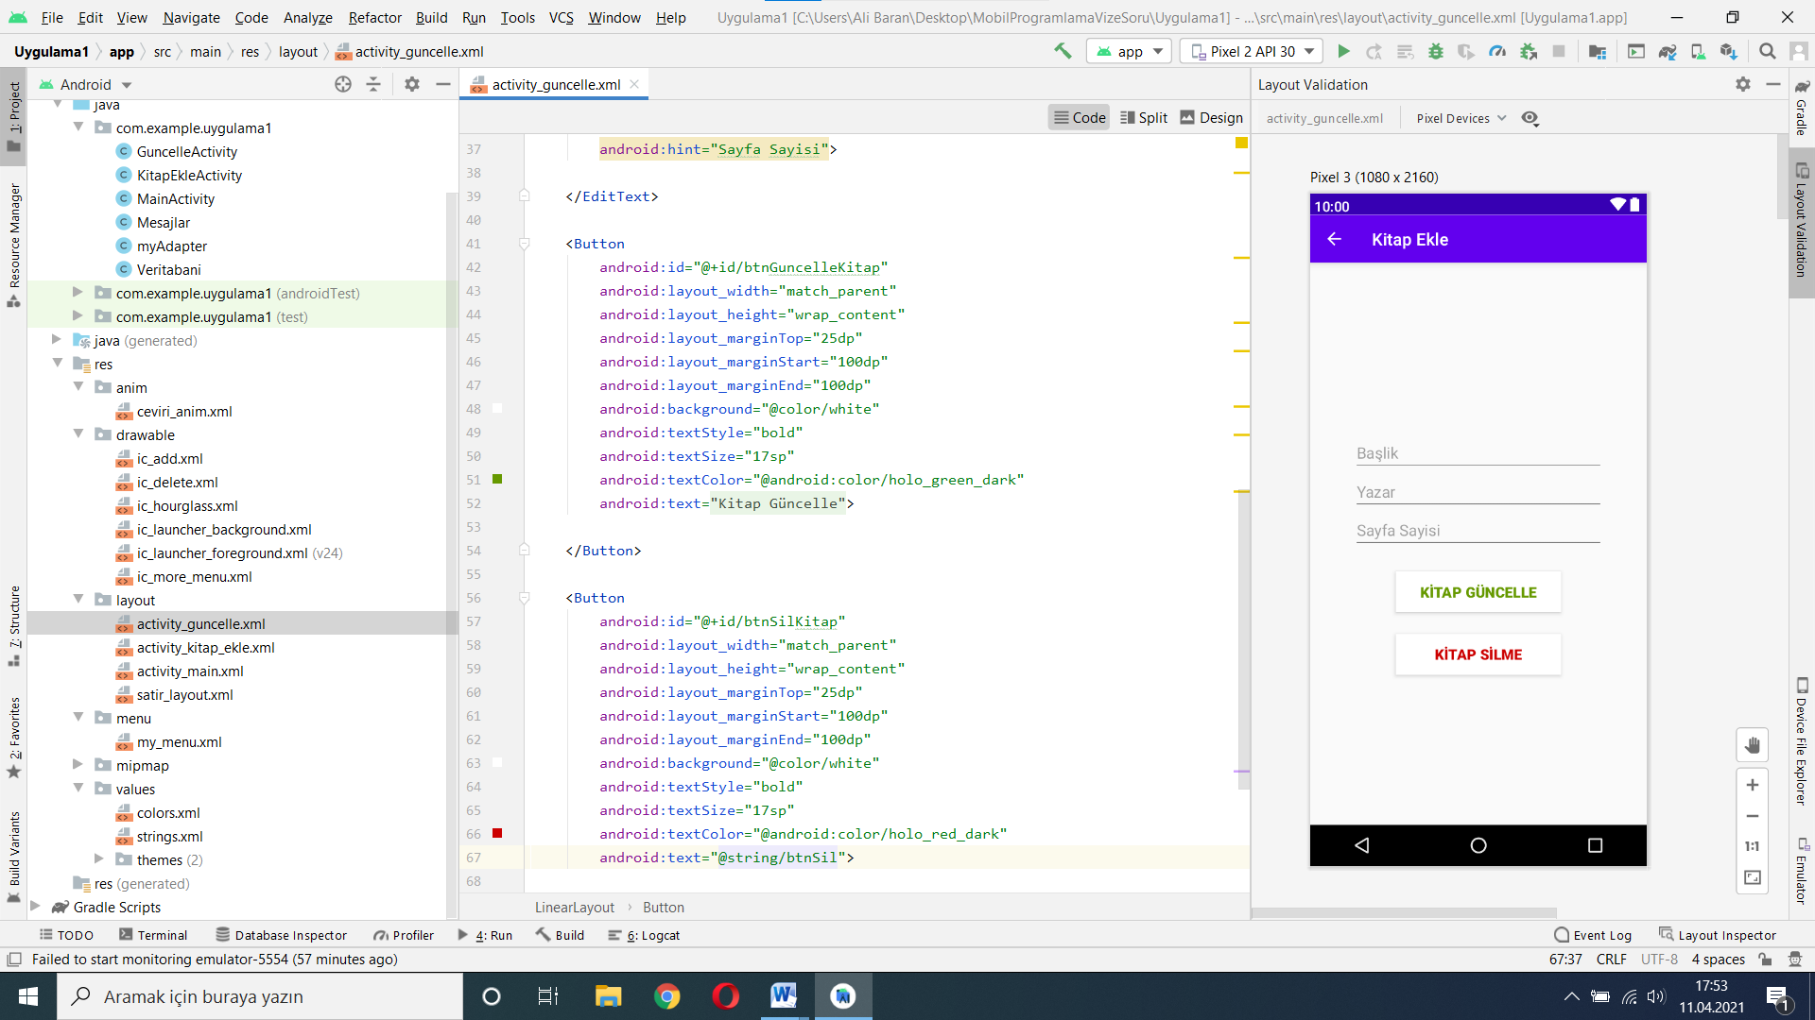

**Şekil 17.activity_guncelle.xml**

KOD KISMI:

*<?*xml version="1.0" encoding="utf-8"*?>*<LinearLayout xmlns:android="http://schemas.android.com/apk/res/android"  
 xmlns:app="http://schemas.android.com/apk/res-auto"  
 xmlns:tools="http://schemas.android.com/tools"  
 android:id="@+id/llGuncelle"  
 android:orientation="vertical"  
 android:layout_width="match_parent"  
 android:layout_height="match_parent"  
 tools:context=".KitapEkleActivity">  
  
  
 <EditText  
 android:id="@+id/etGuncelleBaslik"  
 android:layout_width="match_parent"  
 android:layout_height="wrap_content"  
 android:layout_marginTop="200dp"  
 android:layout_marginStart="50dp"  
 android:layout_marginEnd="50dp"  
 android:hint="Başlik">  
  
 </EditText>  
 <EditText  
 android:id="@+id/etGuncelleYazar"  
 android:layout_width="match_parent"  
 android:layout_height="wrap_content"  
 android:layout_marginStart="50dp"  
 android:layout_marginEnd="50dp"  
 android:hint="Yazar">  
  
 </EditText>  
 <EditText  
 android:id="@+id/etGuncelleSayfaSayisi"  
 android:layout_width="match_parent"  
 android:layout_height="wrap_content"  
 android:layout_marginStart="50dp"  
 android:layout_marginEnd="50dp"  
 android:hint="Sayfa Sayisi">  
  
 </EditText>  
  
 <Button  
 android:id="@+id/btnGuncelleKitap"  
 android:layout_width="match_parent"  
 android:layout_height="wrap_content"  
 android:layout_marginTop="25dp"  
 android:layout_marginStart="100dp"  
 android:layout_marginEnd="100dp"  
 android:background="@color/white"  
 android:textStyle="bold"  
 android:textSize="17sp"  
 android:textColor="@android:color/holo_green_dark"  
 android:text="@string/btnGuncelle">  
  
 </Button>  
  
 <Button  
 android:id="@+id/btnSilKitap"  
 android:layout_width="match_parent"  
 android:layout_height="wrap_content"  
 android:layout_marginTop="25dp"  
 android:layout_marginStart="100dp"  
 android:layout_marginEnd="100dp"  
 android:background="@color/white"  
 android:textStyle="bold"  
 android:textSize="17sp"  
 android:textColor="@android:color/holo_red_dark"  
 android:text="@string/btnSil">  
  
 </Button>  
  
  
  
  
</LinearLayout>

## activity_ekle.xml (10 puan)

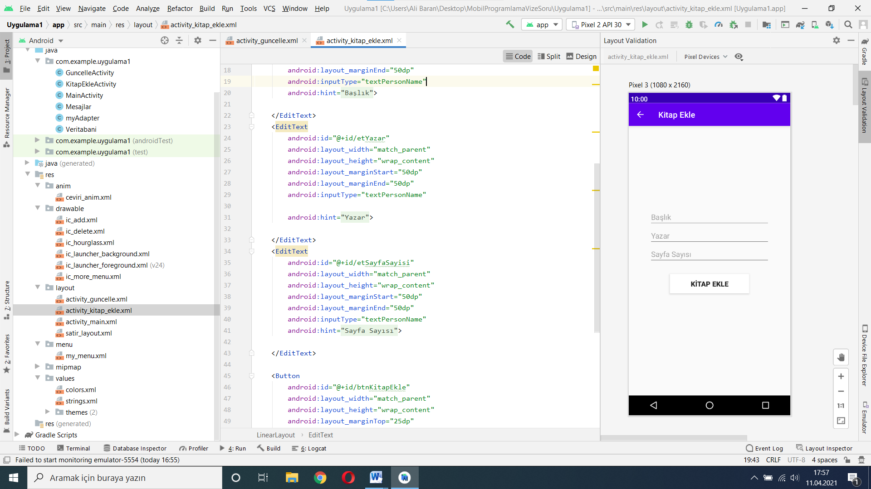

**Şekil18.activity_kitap_ekle.xml**

Kod kısmı:

*<?*xml version="1.0" encoding="utf-8"*?>*<LinearLayout xmlns:android="http://schemas.android.com/apk/res/android"  
 xmlns:app="http://schemas.android.com/apk/res-auto"  
 xmlns:tools="http://schemas.android.com/tools"  
 android:id="@+id/llEkle"  
 android:orientation="vertical"  
 android:layout_width="match_parent"  
 android:layout_height="match_parent"  
 tools:context=".KitapEkleActivity">  
  
  
 <EditText  
 android:id="@+id/etBaslik"  
 android:layout_width="match_parent"  
 android:layout_height="wrap_content"  
 android:layout_marginTop="200dp"  
 android:layout_marginStart="50dp"  
 android:layout_marginEnd="50dp"  
 android:inputType="textPersonName"  
 android:hint="@string/etBaslik">  
  
 </EditText>  
 <EditText  
 android:id="@+id/etYazar"  
 android:layout_width="match_parent"  
 android:layout_height="wrap_content"  
 android:layout_marginStart="50dp"  
 android:layout_marginEnd="50dp"  
 android:inputType="textPersonName"  
  
 android:hint="@string/etYazar">  
  
 </EditText>  
 <EditText  
 android:id="@+id/etSayfaSayisi"  
 android:layout_width="match_parent"  
 android:layout_height="wrap_content"  
 android:layout_marginStart="50dp"  
 android:layout_marginEnd="50dp"  
 android:inputType="textPersonName"  
 android:hint="@string/etSayfaSayisi">  
  
 </EditText>  
  
 <Button  
 android:id="@+id/btnKitapEkle"  
 android:layout_width="match_parent"  
 android:layout_height="wrap_content"  
 android:layout_marginTop="25dp"  
 android:layout_marginStart="100dp"  
 android:layout_marginEnd="100dp"  
 android:background="@color/white"  
 android:textStyle="bold"  
 android:textSize="17sp"  
 android:text="@string/btnKitapEkle">  
  
 </Button>  
  
</LinearLayout>

## Layout_menu.xml (10 puan)

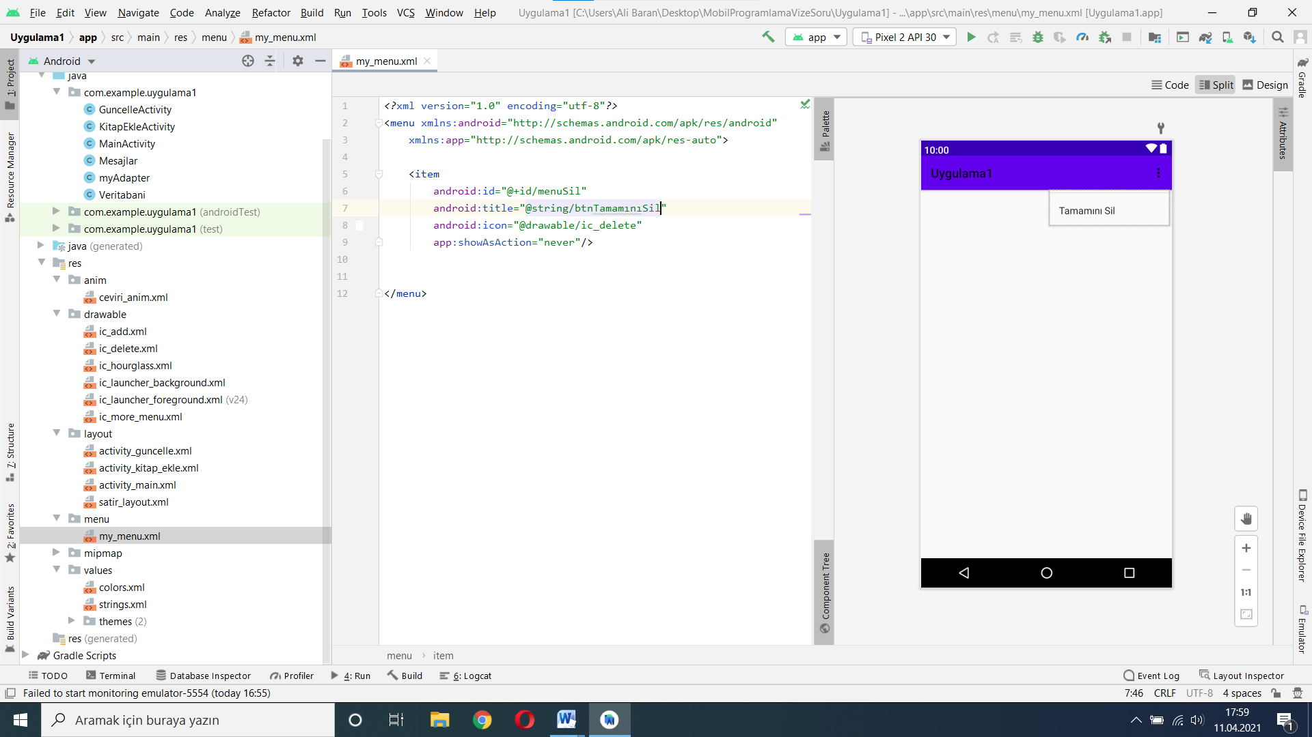

**Şekil 19.my_menu.xml**

## GuncelleActivity.java kodları:

package com.example.uygulama1;  
  
import androidx.appcompat.app.ActionBar;  
import androidx.appcompat.app.AlertDialog;  
import androidx.appcompat.app.AppCompatActivity;  
  
import android.content.DialogInterface;  
import android.os.Bundle;  
import android.view.View;  
import android.widget.Button;  
import android.widget.EditText;  
import android.widget.Toast;  
  
public class GuncelleActivity extends AppCompatActivity {  
  
 EditText guncelle_baslik,guncelle_yazar,guncelle_sayfalar;  
 Button guncelle_kitap_btn,guncelle_SilKitap_btn;  
  
 String id,baslik,yazar,sayfalar;  
  
  
 @Override  
 protected void onCreate(Bundle savedInstanceState) {  
 super.onCreate(savedInstanceState);  
 setContentView(R.layout.*activity_guncelle*);  
  
 guncelle_baslik=findViewById(R.id.*etGuncelleBaslik*);  
 guncelle_yazar=findViewById(R.id.*etGuncelleYazar*);  
 guncelle_sayfalar=findViewById(R.id.*etGuncelleSayfaSayisi*);  
 guncelle_kitap_btn=findViewById(R.id.*btnGuncelleKitap*);  
 guncelle_SilKitap_btn=findViewById(R.id.*btnSilKitap*);  
  
 VeriAlveAta();  
 ActionBar actionBar=getSupportActionBar();  
 if (actionBar != null){  
 actionBar.setTitle(baslik);  
 }  
  
  
 guncelle_kitap_btn.setOnClickListener(new View.OnClickListener() {  
 @Override  
 public void onClick(View v) {  
 Veritabani db=new Veritabani(GuncelleActivity.this);  
 baslik=guncelle_baslik.getText().toString().trim();  
 yazar=guncelle_yazar.getText().toString().trim();  
 sayfalar=guncelle_sayfalar.getText().toString().trim();  
 db.KitapGuncelle(id,baslik,yazar,sayfalar);  
 }  
 });  
  
 guncelle_SilKitap_btn.setOnClickListener(new View.OnClickListener() {  
 @Override  
 public void onClick(View v) {  
 SilmeOnayKutusu();  
 }  
 });  
  
  
 }  
  
 void VeriAlveAta(){  
 if (getIntent().hasExtra("id")  
 && getIntent().hasExtra("baslik")  
 && getIntent().hasExtra("yazar")  
 && getIntent().hasExtra("sayfaSayisi")){  
  
 id=getIntent().getStringExtra("id");  
 baslik=getIntent().getStringExtra("baslik");  
 yazar=getIntent().getStringExtra("yazar");  
 sayfalar=getIntent().getStringExtra("sayfaSayisi");  
  
 guncelle_baslik.setText(baslik);  
 guncelle_yazar.setText(yazar);  
 guncelle_sayfalar.setText(sayfalar);  
 }  
 else{  
 Toast.*makeText*(this,"Veri Yok",Toast.*LENGTH_LONG*).show();  
 }  
 }  
  
 void SilmeOnayKutusu(){  
 AlertDialog.Builder builder=new AlertDialog.Builder(this);  
 builder.setTitle(baslik +" Silmek istiyormusun " + " ?");  
 builder.setMessage(baslik+" kitabını silmek istiyormusun "+" ?");  
 builder.setPositiveButton("Evet", new DialogInterface.OnClickListener() {  
 @Override  
 public void onClick(DialogInterface dialog, int which) {  
 Veritabani db=new Veritabani(GuncelleActivity.this);  
 db.TekKitapSil(id);  
 finish();  
 }  
 });  
 builder.setNegativeButton("Hayır", new DialogInterface.OnClickListener() {  
 @Override  
 public void onClick(DialogInterface dialog, int which) {  
  
 }  
 });  
 builder.create().show();  
 }  
  
  
}

## KitapEkleActivity.jav Kodları:

package com.example.uygulama1;  
  
import androidx.appcompat.app.AppCompatActivity;  
  
import android.os.Bundle;  
import android.view.View;  
import android.widget.Button;  
import android.widget.EditText;  
  
public class KitapEkleActivity extends AppCompatActivity {  
  
 EditText etBaslik,etYazar,etSayfa;  
 Button btn_ekle;  
  
 @Override  
 protected void onCreate(Bundle savedInstanceState) {  
 super.onCreate(savedInstanceState);  
 setContentView(R.layout.*activity_kitap_ekle*);  
  
 etBaslik=findViewById(R.id.*etBaslik*);  
 etYazar=findViewById(R.id.*etYazar*);  
 etSayfa=findViewById(R.id.*etSayfaSayisi*);  
 btn_ekle=findViewById(R.id.*btnKitapEkle*);  
 btn_ekle.setOnClickListener(new View.OnClickListener() {  
 @Override  
 public void onClick(View v) {  
 Veritabani db=new Veritabani(KitapEkleActivity.this);  
 db.KitapEkle(etBaslik.getText().toString().trim(),  
 etYazar.getText().toString().trim(),  
 Integer.*valueOf*(etSayfa.getText().toString().trim()));  
  
 }  
 });  
  
 }  
}

## Mesajlar.java Kodları:

package com.example.uygulama1;  
  
import android.content.Context;  
import android.widget.Toast;  
  
public class Mesajlar {  
  
 public void Onay(long onay, Context context){  
 if (onay==1){  
 Toast.*makeText*(context,"İşlem Başarılı!!",Toast.*LENGTH_LONG*).show();  
 }  
 else{  
 Toast.*makeText*(context,"İşlem Başarısız!!",Toast.*LENGTH_LONG*).show();  
 }  
 }  
  
}

## myAdapter.java Kodları:

package com.example.uygulama1;  
  
import android.app.Activity;  
import android.content.Context;  
import android.content.DialogInterface;  
import android.content.Intent;  
import android.view.LayoutInflater;  
import android.view.View;  
import android.view.ViewGroup;  
import android.view.animation.Animation;  
import android.view.animation.AnimationUtils;  
import android.widget.LinearLayout;  
import android.widget.TextView;  
  
import androidx.annotation.NonNull;  
import androidx.appcompat.app.AlertDialog;  
import androidx.recyclerview.widget.RecyclerView;  
  
import java.util.ArrayList;  
  
public class myAdapter extends RecyclerView.Adapter<myAdapter.ViewHolder> {  
  
 Activity activity;  
 ArrayList kitap_id,kitap_baslik,kitap_yazar,kitap_sayfalar;  
 Context context;  
  
 Animation ceviri_anim;  
  
 myAdapter(Activity activity,Context context,ArrayList kitap_id,ArrayList kitap_baslik,ArrayList kitap_yazar,ArrayList kitap_sayfalar){  
 this.activity=activity;  
 this.context=context;  
 this.kitap_id=kitap_id;  
 this.kitap_baslik=kitap_baslik;  
 this.kitap_yazar=kitap_yazar;  
 this.kitap_sayfalar=kitap_sayfalar;  
  
 }  
  
 @NonNull  
 @Override  
 public ViewHolder onCreateViewHolder(@NonNull ViewGroup parent, int viewType) {  
 LayoutInflater inflater=LayoutInflater.*from*(context);  
 View view=inflater.inflate(R.layout.*satir_layout*,parent,false);  
 ViewHolder viewHolder=new ViewHolder(view);  
 return viewHolder;  
 }  
  
 @Override  
 public void onBindViewHolder(@NonNull ViewHolder holder, int position) {  
  
 holder.txt_kitap_id.setText(String.*valueOf*(kitap_id.get(position)));  
 holder.txt_kitap_baslik.setText(String.*valueOf*(kitap_baslik.get(position)));  
 holder.txt_kitap_yazar.setText(String.*valueOf*(kitap_yazar.get(position)));  
 holder.txt_kitap_sayfalar.setText(String.*valueOf*(kitap_sayfalar.get(position)));  
 holder.llsatir.setOnClickListener(new View.OnClickListener() {  
 @Override  
 public void onClick(View v) {  
 Intent intent=new Intent(context,GuncelleActivity.class);  
 intent.putExtra("id",String.*valueOf*(kitap_id.get(position)));  
 intent.putExtra("baslik",String.*valueOf*(kitap_baslik.get(position)));  
 intent.putExtra("yazar",String.*valueOf*(kitap_yazar.get(position)));  
 intent.putExtra("sayfaSayisi",String.*valueOf*(kitap_sayfalar.get(position)));  
 activity.startActivityForResult(intent,1);  
  
 }  
 });  
  
 }  
  
 @Override  
 public int getItemCount() {  
 return kitap_id.size();  
 }  
  
 public class ViewHolder extends RecyclerView.ViewHolder {  
 LinearLayout llsatir;  
 TextView txt_kitap_id,txt_kitap_baslik,txt_kitap_yazar,txt_kitap_sayfalar;  
 public ViewHolder(@NonNull View itemView) {  
 super(itemView);  
 txt_kitap_id=itemView.findViewById(R.id.*txt_kitap_id*);  
 txt_kitap_baslik=itemView.findViewById(R.id.*txt_kitap_baslik*);  
 txt_kitap_yazar=itemView.findViewById(R.id.*txt_kitap_yazar*);  
 txt_kitap_sayfalar=itemView.findViewById(R.id.*txt_kitap_sayfalar*);  
 llsatir=itemView.findViewById(R.id.*llsatir*);  
 ceviri_anim= AnimationUtils.*loadAnimation*(context,R.anim.*ceviri_anim*);  
 llsatir.setAnimation(ceviri_anim);  
  
 }  
 }  
  
  
  
}

## Veritabani.java Kodları:

package com.example.uygulama1;  
  
import android.content.ContentValues;  
import android.content.Context;  
import android.database.Cursor;  
import android.database.sqlite.SQLiteDatabase;  
import android.database.sqlite.SQLiteOpenHelper;  
import android.widget.Toast;  
  
import androidx.annotation.Nullable;  
  
public class Veritabani extends SQLiteOpenHelper {  
  
 private static final String *DATABASE_NAME*="Kutuphane1.db";  
 private static final int *DATABASE_VERSION*=1;  
  
 private static final String *TABLO_AD*="Kitaplık";  
 private static final String *ROW_ID*="id";  
 private static final String *ROW_BASLIK*="kBaslik";  
 private static final String *ROW_YAZAR*="kYazar";  
 private static final String *ROW_SAYFA*="kSayfaSayisi";  
 private Context context;  
  
  
 Veritabani(@Nullable Context context) {  
 super(context, *DATABASE_NAME*, null, *DATABASE_VERSION*);  
 this.context=context;  
 }  
  
 @Override  
 public void onCreate(SQLiteDatabase db) {  
 db.execSQL("CREATE TABLE " + *TABLO_AD* +  
 " (" + *ROW_ID* + " INTEGER PRIMARY KEY AUTOINCREMENT, " +  
 *ROW_BASLIK* + " TEXT, " +  
 *ROW_YAZAR* + " TEXT, " +  
 *ROW_SAYFA* + " INTEGER)");  
  
 }  
  
 @Override  
 public void onUpgrade(SQLiteDatabase db, int oldVersion, int newVersion) {  
 db.execSQL("DROP TABLE IF EXISTS "+ *TABLO_AD*);  
 onCreate(db);  
 }  
  
 void KitapEkle(String baslik,String yazar,int sayfalar){  
 SQLiteDatabase db=this.getWritableDatabase();  
 ContentValues cv=new ContentValues();  
  
 cv.put(*ROW_BASLIK*,baslik);  
 cv.put(*ROW_YAZAR*,yazar);  
 cv.put(*ROW_SAYFA*,sayfalar);  
 long onay=db.insert(*TABLO_AD*,null,cv);  
 Mesajlar ms=new Mesajlar();  
 ms.Onay(onay,context);  
 }  
  
 Cursor KitapListele(){  
 String sorgu="SELECT * FROM " + *TABLO_AD*;  
 SQLiteDatabase db=this.getReadableDatabase();  
  
 Cursor cursor=null;  
 if (db != null)  
 {  
 cursor=db.rawQuery(sorgu,null);  
 }  
 return cursor;  
 }  
  
 void KitapGuncelle(String id,String baslik,String yazar,String sayfalar){  
 SQLiteDatabase db=this.getWritableDatabase();  
 ContentValues cv=new ContentValues();  
 cv.put(*ROW_BASLIK*, baslik);  
 cv.put(*ROW_YAZAR*, yazar);  
 cv.put(*ROW_SAYFA*, sayfalar);  
  
 long onay =db.update(*TABLO_AD*,cv," id=?",new String[]{id});  
 Mesajlar ms=new Mesajlar();  
 ms.Onay(onay,context);  
  
 }  
  
 void TekKitapSil(String id){  
 SQLiteDatabase db=this.getWritableDatabase();  
 long onay=db.delete(*TABLO_AD*,"id=?",new String[]{id});  
 Mesajlar ms=new Mesajlar();  
 ms.Onay(onay,context);  
 }  
  
 void HepsiniKitapSil(){  
 SQLiteDatabase db=this.getWritableDatabase();  
 db.execSQL("DELETE FROM " + *TABLO_AD*);  
 }  
  
  
}

## AndroidManifast.xml

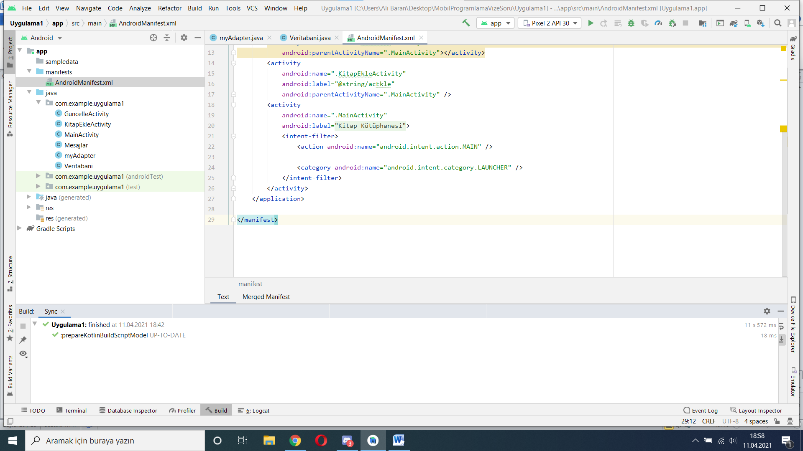

Kodları:

*<?*xml version="1.0" encoding="utf-8"*?>*<manifest xmlns:android="http://schemas.android.com/apk/res/android"  
 package="com.example.uygulama1">  
  
 <application  
 android:allowBackup="true"  
 android:icon="@mipmap/ic_launcher"  
 android:label="@string/app_name"  
 android:roundIcon="@mipmap/ic_launcher_round"  
 android:supportsRtl="true"  
 android:theme="@style/Theme.Uygulama1">  
 <activity android:name=".GuncelleActivity"  
 android:parentActivityName=".MainActivity"></activity>  
 <activity  
 android:name=".KitapEkleActivity"  
 android:label="@string/acEkle"  
 android:parentActivityName=".MainActivity" />  
 <activity  
 android:name=".MainActivity"  
 android:label="@string/uygulamaAdi">  
 <intent-filter>  
 <action android:name="android.intent.action.MAIN" />  
  
 <category android:name="android.intent.category.LAUNCHER" />  
 </intent-filter>  
 </activity>  
 </application>  
  
</manifest>

# SON